2020 ANNUAL ROADS REPORT
Roads Commission Annual Review:
2020 Projects Completed:
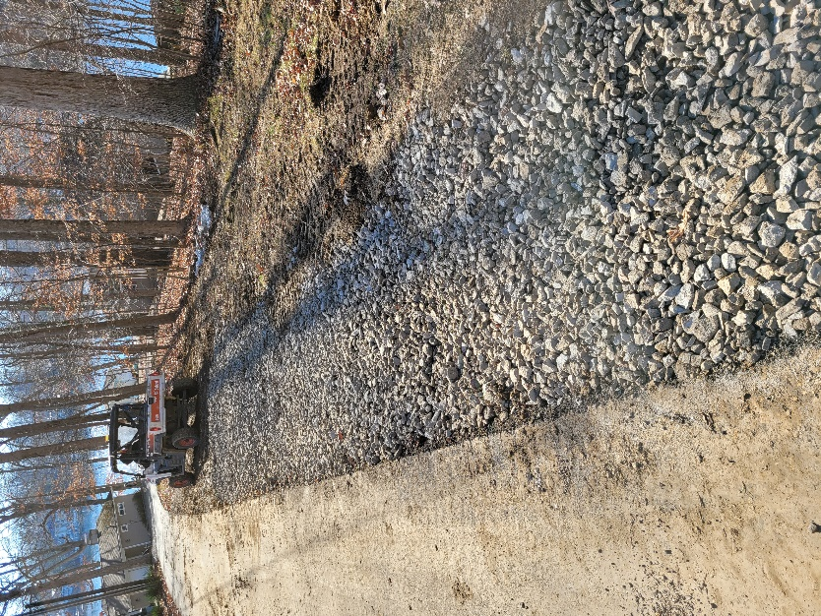
- Patch and overlay on Sweetwater Drive (Duck to Eagle, patch-only), both back-gates, Alder, Elm, Ebony, Nuthatch, and Eagle Drive (patch-only)
- New culverts installed on Pheasant Drive and Lion Drive
- Erosion control work completed on Robin Court and Grizzly Drive
- Added stone shoulders throughout main roads

2021 Planned Projects:
- Install catch-basins on Duck Ct and Sweetwater Dr
- Ditching along Sweetwater Drive
- Extensive work on Elk Drive including ditching and erosion control textiles
- Pavement repairs on Cougar, Groundhog, Gopher, and Grizzly

Other:
- 281 work orders completed in 2020 with 634 labor hours expended on Streets. Total cost on Streets in 2020 was $371,780.
- 13 Winter Weather Events in 2020 with 74 labor hours expended
- Wagler Brothers spread gravel on streets 42 times in 2020

