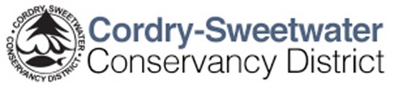
Ecology Commission/ Zebra Mussel Prevention Committee
7:00 PM March 23rd, 2021
CSLOA Clubhouse

Agenda

- Introductions
- Best practices/ procedures for boats & trailers that have been in other lakes
  - Washing
  - Drying
  - Chemicals
- Barge permits from the CSCD
  - Rule recommendation
  - Implementation
    - Communication
    - Timing
    - Procedures
  - Enforcement
- Boat trailering companies
  - Rule recommendation
  - Implementation
    - Communication
    - Timing
    - Procedures
  - Enforcement
- Brainstorm ideas for future implementation of Freeholder multi-lake users (If time permits)

