2020 ECOLOGY REPORT
ECOLOGY Commission Annual Review:

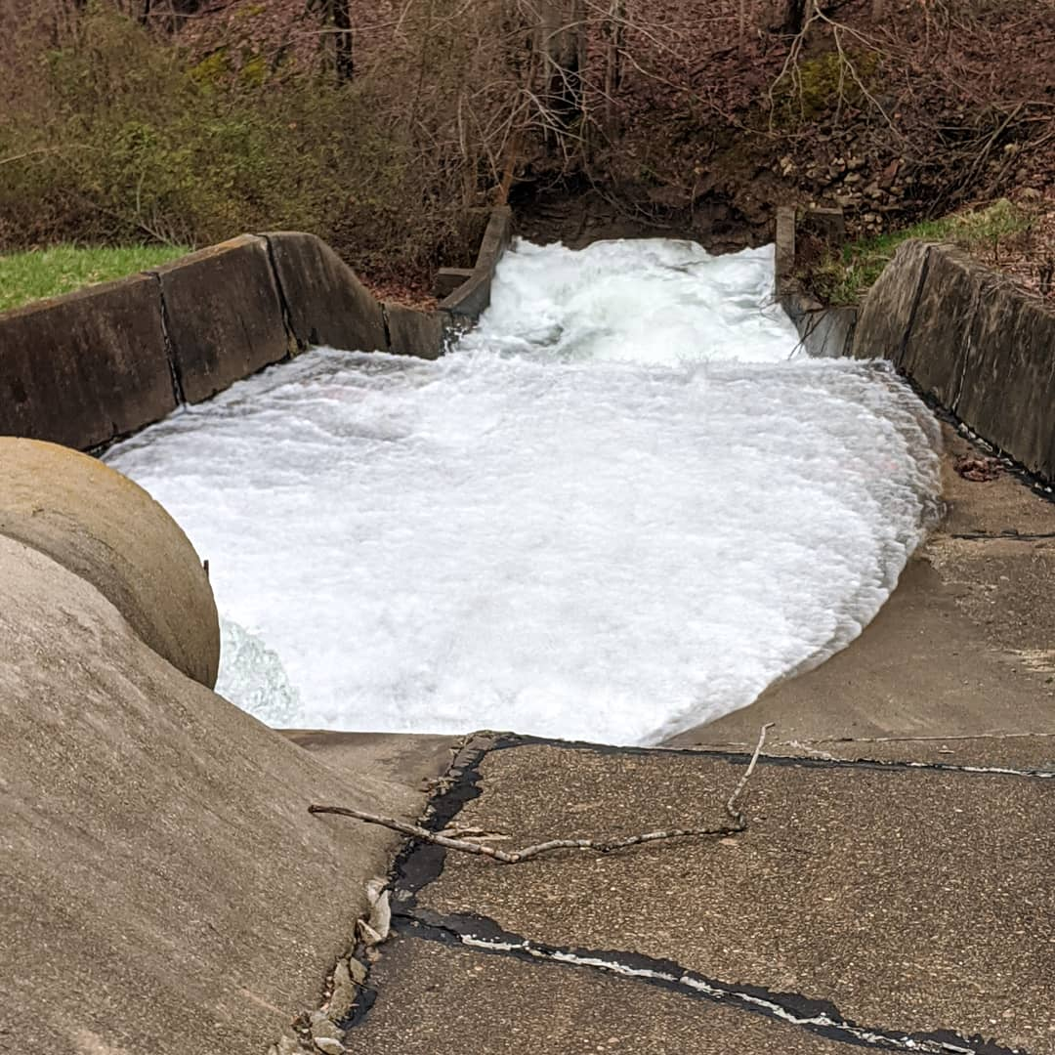
Completed Projects:
- Trail 6 constructed between CSCD Office and Clubhouse
- Pickleball Courts painted on Centerlake Park Basketball Court
- All buoys GPS marked and added to GIS
- Coffer dam work completed on Antelope, Grizzly, and Groundhog
- Core samples taken from Cordry Dam Spillway
- GPS all CSCD Hiking Trails and added to public GIS map
- Replaced decking at old Beach House

2020 Projects
- Cordry Dam Spillway engineering and design
- Create pollinator habitat across from beach
- Coffer Dam restoration possible on Cougar Drive & Bass CT/ Centerlake as funds are available
- Improve rest room access at Centerlake Park
- Improve communication and measures to prevent Zebra Mussel infestations
- Coordinating with CSLOA on a “Welcome-Packet” for new Freeholders that will include a Parks & Rec brochure and other Ecology-related media

Other
- 272 Ecology-related work orders completed with 558 labor hours expended; most hours expended mowing, raking the beach, and pushing the leaves at the compost pile
- 2020 Deer Reduction Hunt once again completed with no safety violations; 18 deer have been harvested in this season’s hunt

