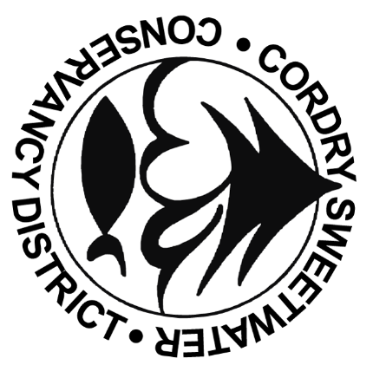
Cordry-Sweetwater Conservancy District

8377 CORDRY DRIVE NINEVEH, IN 46164
PHONE: 317-933-2893 FAX: 317-933-3628

Board of Directors Meeting Agenda
May 21st, 2024, 7:00 PM @ CSLOA
Also available online live at www.cscd-in.org

- Welcome & Pledge of Allegiance

- Agenda Modifications

- Approval of Minutes:
  - April 16th, 2024, Board Meeting Minutes
  - April 23rd, 2024, Special Session Minutes

- Freeholder Concerns: (Please limit time to three minutes)

- Staff Reports:
  - Director of Finance & Administration: Brittany Bay
    - Approval of Financial Reports
    - Approval of Claims
  - Director of Operations & BCO: Nick Johann’s Report

- Commission/Committee Reports:
  - Building- Pat Sherman
    - Building Applications
    - Variance Request
    - Cougar Dr. - Easement
  - Ecology- Randy Brumfield
    - Wake Study – Dr. Sweeten
  - Roads -Mark Rasdall
  - Security -Jim Maulden
  - Water- Aaron Parris

- Old Business
  - Approving Resolution 2024-10 Allowing non-motorized watercraft on lakes during red light

- New Business
  - Patrick Sherman – Policies & Procedures for Office of District Marshall

- Board Member Concerns/Comments

- Adjourn

