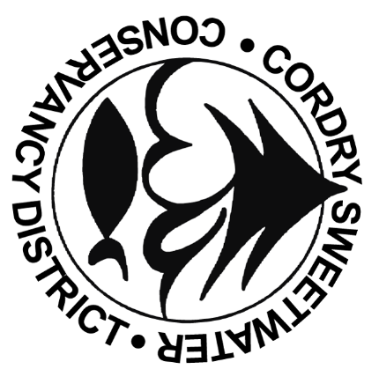**Cordry-Sweetwater Conservancy District**

**8377 CORDRY DRIVE NINEVEH, IN 46164**

**PHONE: 317-933-2893 FAX: 317-933-3628**

Board of Directors Meeting Agenda

**September 17th, 2024, 7:00 PM @ CSLOA**

**Also available online live at** [**www.cscd-in.org**](http://www.cscd-in.org)

1. Welcome & Pledge of Allegiance
2. Agenda Modifications
3. Approval of Minutes:
   1. August 20th Executive Board Meeting Minutes
   2. August 20th Board Meeting Minutes
   3. August 26th Special Session Meeting Minutes
4. Bond Issuance – Patrick Sherman
5. Freeholder Concerns: (Please limit time to three minutes)
6. Staff Reports:
   1. Director of Finance & Administration: Brittany Bay
      1. Resolution 2024-16: Transfer of funds within the Budget
      2. Approval of Financial Reports
      3. Approval of Claims
   2. Director of Operations & BCO: Nick Johann’s Report
7. Commission/Committee Reports:
   1. Building- Pat Sherman
      1. Building Applications
      2. Dredging Requests
   2. Ecology- Randy Brumfield
   3. Roads -Mark Rasdall
   4. Security -Jim Maulden
   5. Water- Aaron Parris
8. Old Business
   1. Election Issues
9. New Business
   1. Public Reading of 2025 Budget
10. Board Member Concerns/Comments
11. Adjourn